# OBO - Object Overview

The object overview screen gives you access to all records related to a process. In this instance we will be using it to hold our extension request data.

## OBI - Object Instance

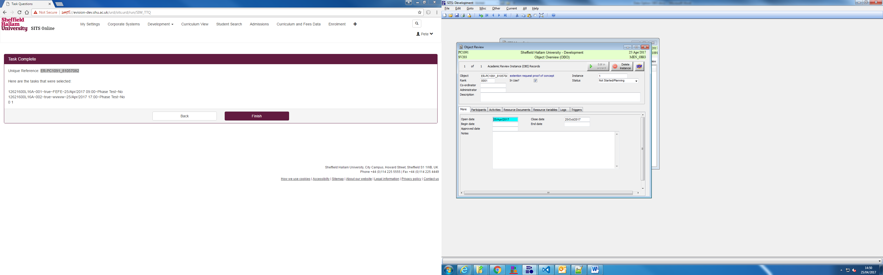

Provides open date and estimated close date (useful for clean-up).

There is also a notes field to store any information against the request as a whole.

## OBP - Participants

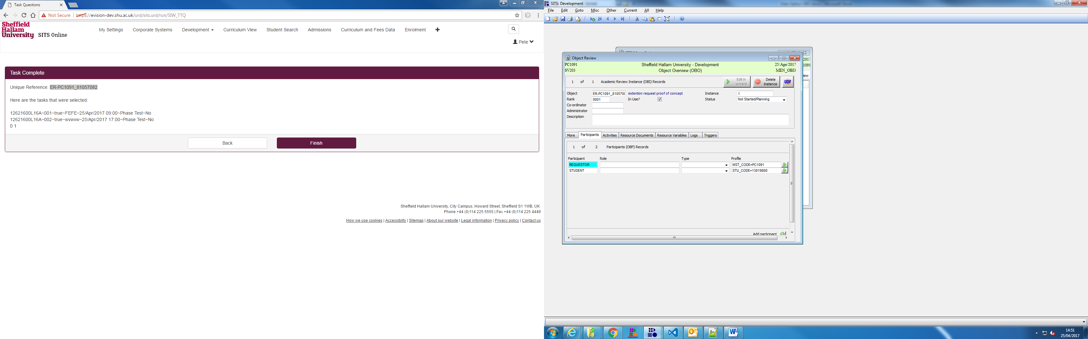

Participants screen -

Allows you to see the student info and the requestor info (if the request was submitted on behalf of the student by a member of staff)

## OBR - Object Resources overview

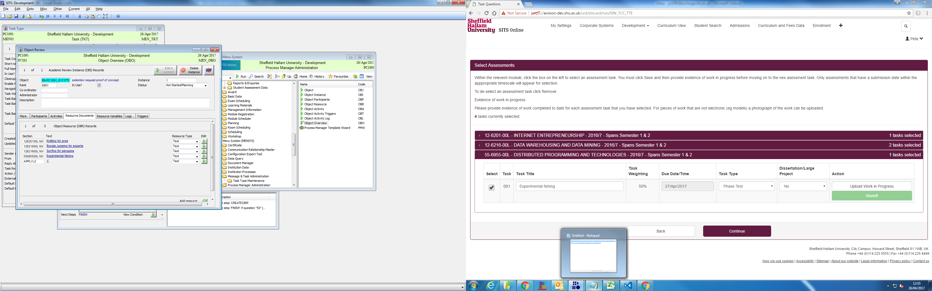

An OBR is a generic record which we will use to store task, and other request related information.

The screen in OBO gives a high level view - you would be able to see from here how many tasks the student is wanting to request against, the overall status of the request, and whether a learning contract needs to be taken into consideration.

We will also store the answers provided to the student on the summary page on this screen.

## OBR - OBR edit screen

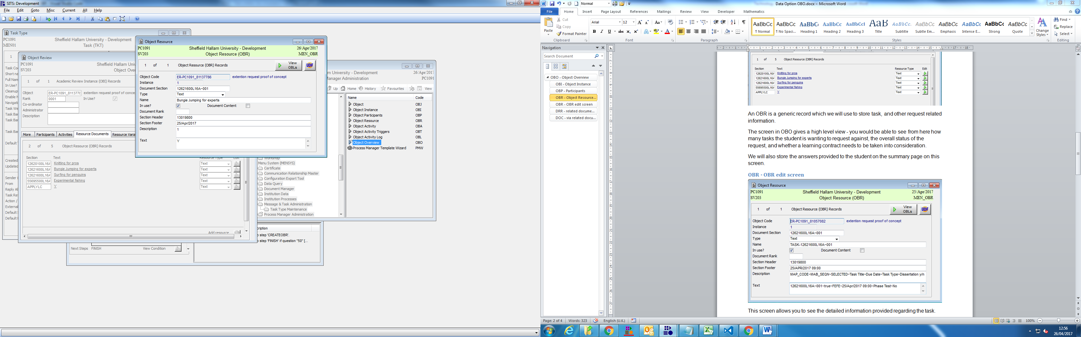

This screen allows you to see the detailed information provided regarding the task.

This data is primarily intended to be used in e-vision so is in machine friendly format.

This could be turned into a more human friendly record - would would just need a new OBR for every piece of data.

The in-use field is used to show whether the OBR is part of the request or not.

## DRR - related documents

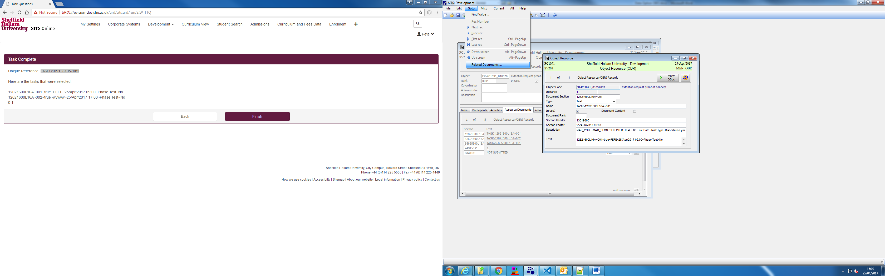

By going to related records, the client will search for any DRRs (document related records) and display any documents that are related to the task. If they are found, you will be able to view them.

DRRs will be created via the e-vision upload process.

## DOC - via related documents

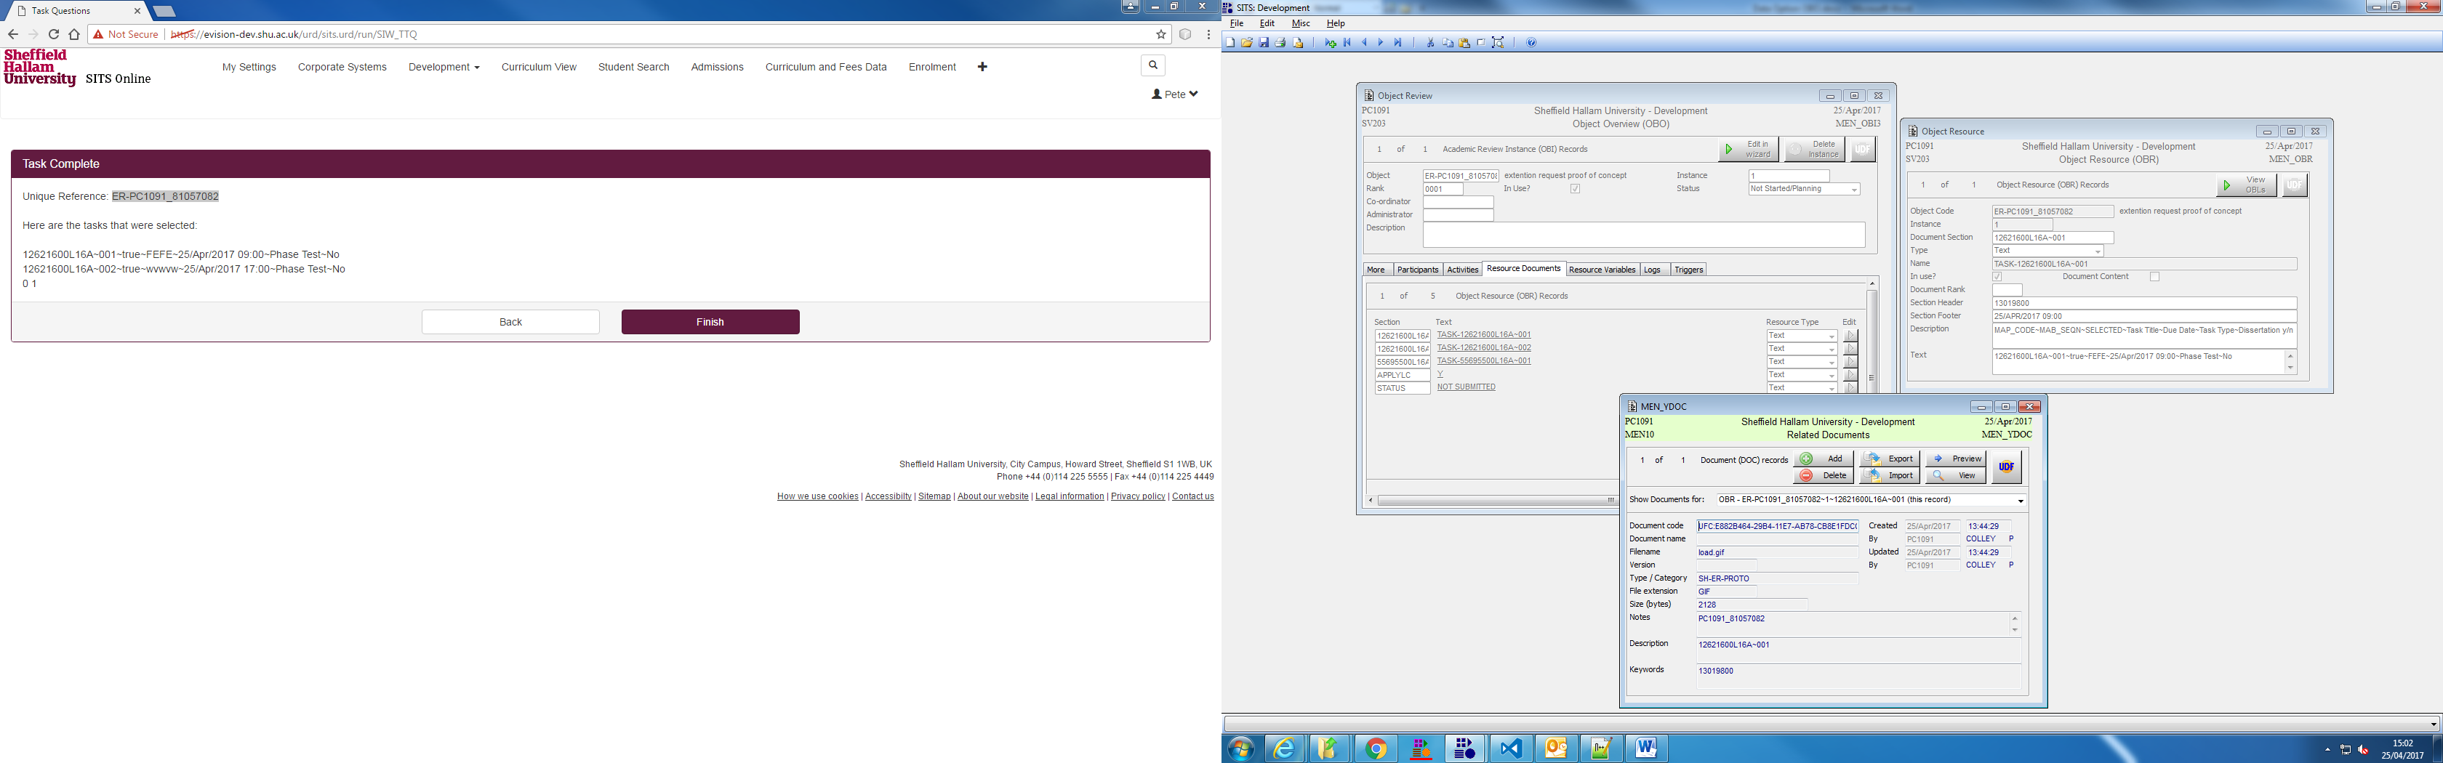

You can see the request, tasks, task info and related evidence, all from a single screen tied together by the request ID.

## SRL -Views

On the OBR and OBO screens, going to generate -> letter and generating the letter SH-ER-VIEW will create a nicely formatted version of the screen you are looking at. This will make it far easier to troubleshoot records that have hijacked fields for data storage eg. document content (dissertation/large project?)

